COS 226 Algorithms and Data Structures Spring 2008

Final
This test has 12 questions worth a total of 100 points. You have 180 minutes. The exam is closed book, except that you are allowed to use a one page cheatsheet (8.5-by-11, in your own handwriting). No calculators or other electronic devices are permitted. Give your answers and show your work in the space provided. Write out and sign the Honor Code pledge before turning in the test.
“I pledge my honor that I have not violated the Honor Code during this examination.”
Problem | Score | Problem | Score
1 |  | 7
2 |  | 8
3 |  | 9
4 |  | 10
5 |  | 11
6 |  | 12
Sub 1 |  | Sub 2
Total

Name:
Login ID:
Precept:
P01 12:30 Moses P01A 12:30 Szymon P02 1:30 Szymon P02A 1:30 Moses P03 3:30 Nadia
1
1. Graph search. (10 points) Consider the following directed graph.
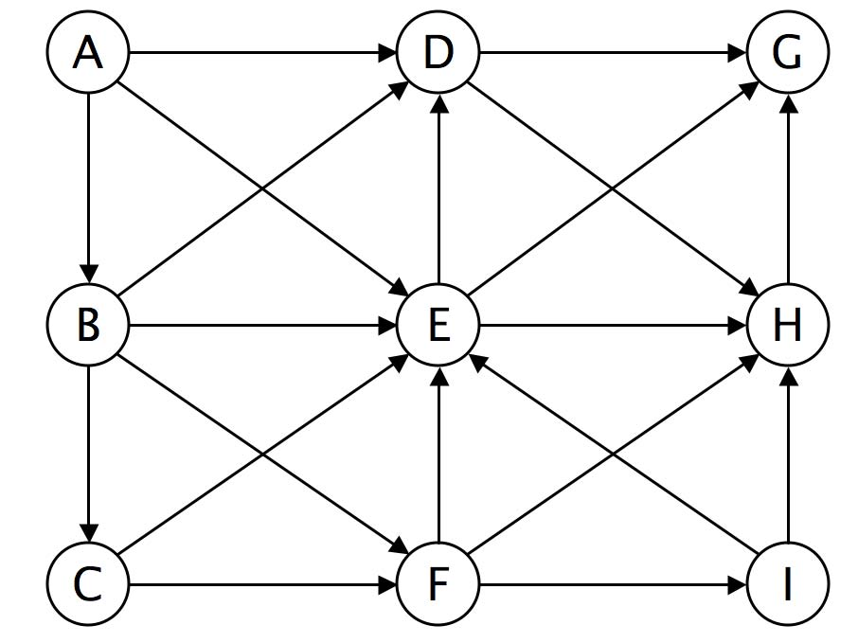
(a) Run depth-ﬁrst search, starting at vertex A. Assume the adjacency lists are in lexicographic order, e.g., when exploring vertex E, consider E-D before E-G or E-H. Complete the list of vertices in preorder (the order they are ﬁrst discovered by DFS).
A B C ___ ___ ___ ___ ___ ___
(b) Run breadth-ﬁrst search, starting at vertex A. Assume the adjacency lists are in lexicographic order. Complete the list of vertices in the order in which they are enqueued.
ABD E_______________
(c) Identify one situation where you would need to use BFS instead of DFS.
(d) Identify one situation where you would need to use DFS instead of BFS.

2. Minimum spanning tree. (8 points) Consider the following weighted graph.
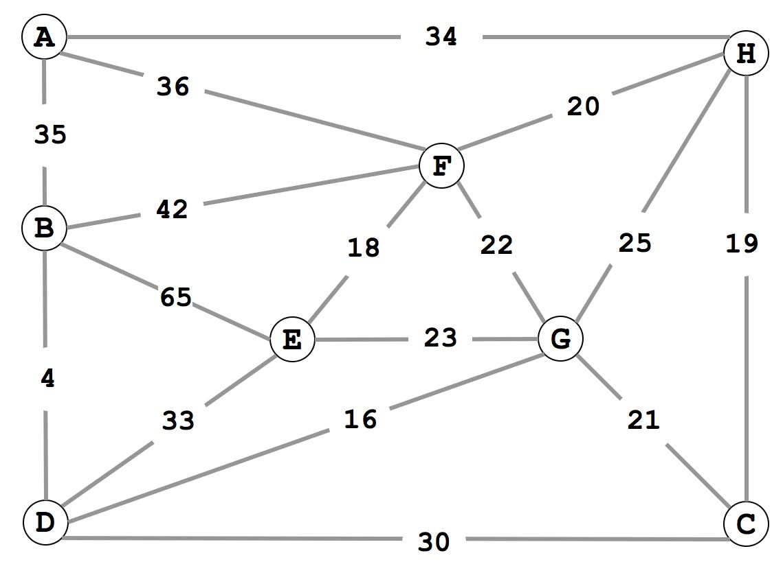
(a) Complete the list of edges in the MST in the order that Kruskal’s algorithm includes them. For reference, the edge weights in ascending order are:
4 16 18 19 20 21 22 23 25 30 33 34 35 36 42 65
B-D ____ ____ ____ ____ ____ ____
(b) Complete the list of edges in the MST in the order that Prim’s algorithm includes them. Start Prim’s algorithm from vertex A.
A-H ____ ____ ____ ____ ____ ____
3. Minimum spanning tree. (8 points) Suppose you know the MST of a weighted graph G. Now, a new edge v-w of weight c is
inserted into G to form a weighted graph G/. Design an O(V ) time algorithm to determine if the MST in G is also an MST in G/. You may assume all edge weights are distinct. Your answer will be graded for correctness, clarity, and conciseness.
(a) State the algorithm.
(b) Explain brieﬂy why it takes O(V ) time.

4. Data compression. (4 points)
How many bits are in the Huﬀman encoding of the following message? (Do not count the bits to encode the table.)
abaabacabaabacdabaabacabaabacde
For reference, the frequency of each symbol is given in the table below.
a | b | c | d | e
16 | 8 | 4 | 2 | 1

5. Ternary search tries. (6 points) Consider the following TST, where the black nodes correspond to strings in the TST.
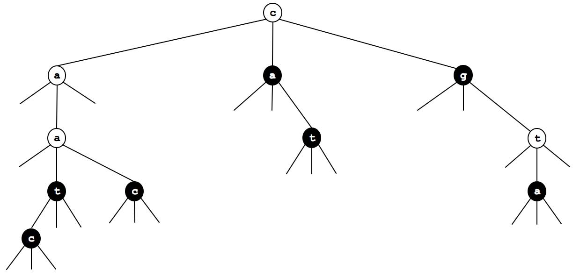
(a) Which 7 strings (in alphabetical order) are in the TST?
(b) Draw the results of adding the following strings into the TST above:

cgt aaca tt
6. String searching. (8 points)
Complete the following DFA to match precisely those strings (over the two letter alphabet) that contain bababba as a substring. State 0 is the start state and state 7 is the accept state.
0 |  | 1 | 2 | 3 | 4 | 5 | 6 | 7
a | 0 | 2 | 0 | 4 | 0 |  |  | 7
b | 1 | 1 | 3 | 1 | 5 |  |  | 7

7. Algorithm matching. (10 points)
Match up each application with an algorithm or data structure that we used to solve it in this course. Use each answer exactly once.
−−− | T9 texting in a cell phone |  |  |  |  | A. Trie
−−− | 1D range search |  |  |  |  | B. Hashing
−−− | 2D range search |  |  |  |  | C. 3-way radix quicksort
−−− | Document similarity |  |  |  |  | D. Binary search tree
−−− | Traveling salesperson problem |  |  |  |  | E. Kd tree
−−− | Sudoku solver |  |  |  |  | F. Depth-ﬁrst search
−−− | Arbitrage detection in currency exchange rates |  |  |  |  | G. Breadth-ﬁrst search
−−− | Mark-sweep garbage collector |  |  |  |  | H. Dijkstra’s algorithm
−−− | Web crawler |  |  |  |  | I. Topological sort
−−− | Google maps |  |  |  |  | J. Bellman-Ford
−−− | PERT/CPM | (Program | Evaluation | and | Review | K. Enumerate permutations
 | Technique / Critical Path Method). |  |  |  |  | L. Enumerate base-R integers
−−− | Longest repeated substring

8. Regular expressions. (8 points) Draw the NFA that results from the RE-to-NFA conversion algorithm described in lecture
when applied to the regular expression (a | (bc)*) d*. Label the start state 0, the accept state 1, and remaining states in the order they are created by the RE-to-NFA algorithm.
9. Convex hull. (8 points)
Run the Graham scan algorithm to compute the convex hull of the 9 points below, using F as the base point, and continuing counterclockwise starting at G.
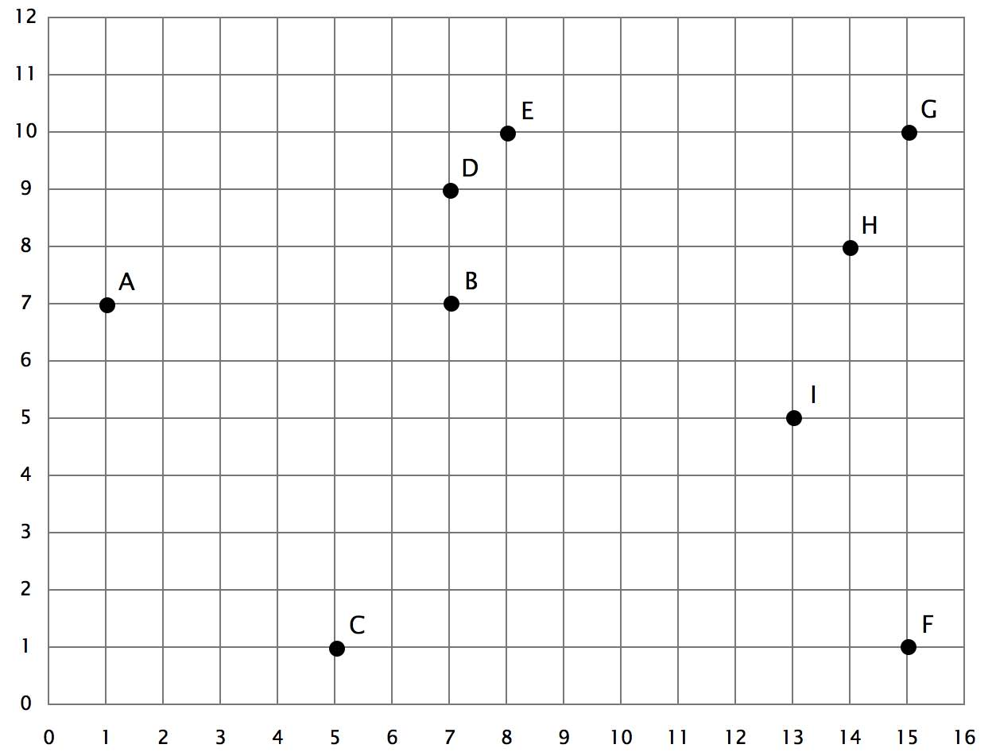
(a) List the points in the order that they are considered for insertion into the convex hull.
F G H I ___ ___ ___ ___ ___
(b) Give the points that appear on the trial hull (after each of the remaining iterations).
- F->G->H
- F->G->H->I

10. 4-sum. (12 points) Consider the 4-sum problem: Given N integers, do any 4 of them sum up to exactly 0?
(a) Consider the following brute-force solution (we ignore integer overﬂow).
public static fourSum(int[] a) { int N = a.length; for (int i = 0; i < N; i++)
for (int j = i+1; j < N; j++) for (int k = j+1; k < N; k++) for (int l = k+1; l < N; l++) if (a[i] + a[j] + a[k] + a[l] == 0) return true; return false; }
What is the order of growth of the worst-case running time? Circle the best answer.
NN log NN2 N3 N4 2N
(b) Design an algorithm for 4-sum that runs in O(N2) time and uses O(N2) memory.
Assume that you have access to a hashing-based symbol table that can put() and get() integer keys in constant time per operation.
11. Reductions and shortest paths. (10 points) Given a digraph G, a distinguished vertex s, and nonnegative vertex weights, the single-source
vertex-weighted shortest path problem is to to ﬁnd the shortest path from s to each vertex, where the length of the path is the sum of the weights of the vertices on the path.
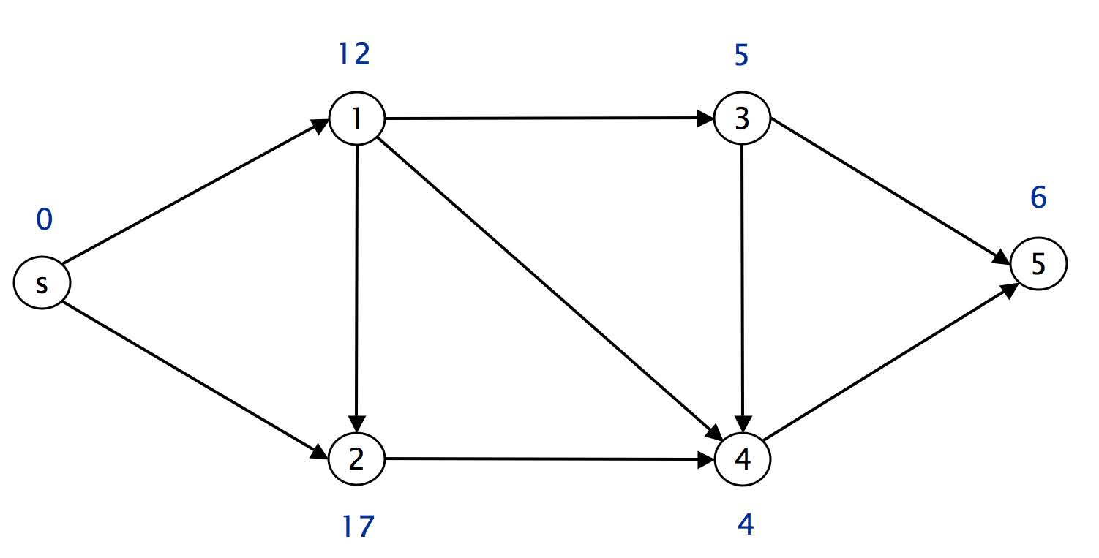
Figure 1: The shortest path from s to 5 is s − 1 − 4 − 5 and has length 22.
Give a linear-time reduction from the single-source vertex-weighted shortest path problem to the classic single-source edge-weighted shortest path problem. Demonstrate your reduction by drawing the corresponding digraph G/ along with its edge weights.
12. Suﬃx sorting. (8 points) Your Harvard friend is trying to sort the suﬃxes of a string s consisting of N ASCII characters,
none of which is ’\0’. The code calls RadixQuicksort3way.sort(), which sorts an array of ’\0’-terminated strings.
// form the N suffixes, appending ’\0’ to the end of each string String[] suffixes = new String[N]; for (int i = 0; i < N; i++) {
suffixes[i] = s.substring(i, N) + "\0"; }
// sort the N strings
RadixQuicksort3way.sort(suffixes);
Unfortunately, when your friend uses this code for large N, it fails spectacularly, even for non-pathological inputs.
(a) Brieﬂy explain the problem.
(b) Fix it so that it runs eﬃciently.

11

